Habitat for Humanity Spring Break Trip
HEADLINE: Marist Students Volunteer for Habitat for Humanity over Spring Break

SUMMARY: Ten Marist students traveled to Louisiana to build homes for families in need

BACK-END TITLE: Students Habitat for Humanity

[PHOTOS CAN BE FOUND HERE WITH COURTESIES NOTED: https://spaces.hightail.com/space/1pGnhSNbCA]

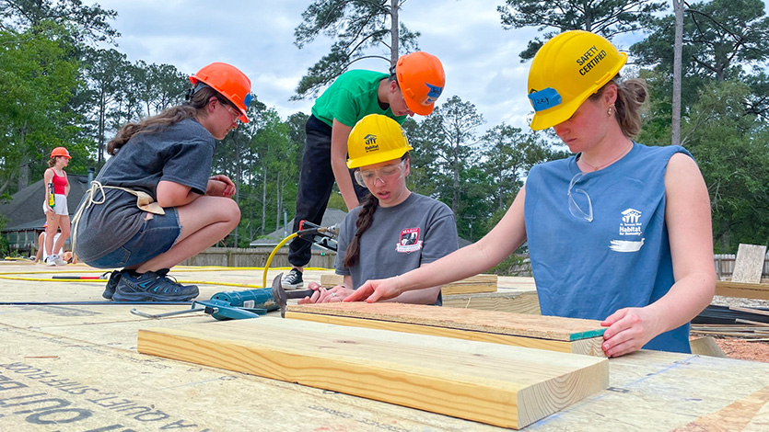
Marist students work on a home in Louisiana for Habitat for Humanity during spring break. Photos by Marisa Moore and Caroline Cmielewski ‘25.

March 31, 2023 – Spring break is a time to disconnect from school work and recharge for the final two months of the academic year. However, a group of Marist students dedicated their week off to helping families in need. The College’s Habitat for Humanity Club traveled to Louisiana, where 10 Marist students, led by advisors from Counseling Services, worked on building new homes near New Orleans.

The trip was part of Habitat for Humanity’s Collegiate Challenge, which organizes volunteer efforts from college students around the country during their spring break. Marist, which has a long history of volunteerism and service learning, participates in this challenge each year. Students’ daily work included vinyl siding, decking, framing, and painting projects.

“The Marist group formed lasting relationships and impressed the local chapter with their work ethic, ability, and the fun they brought to the worksite,” said Eileen Mastrantuono, Counseling Services Coordinator at Marist. “They had the opportunity to hear more about New Orleans culture, taste some of the local food, and learn more about the devastating impacts from Hurricane Katrina that can still be felt in the area. I feel so privileged to have worked with such an amazing group of Marist students.”

Marist students who made the trip also got in some sightseeing around New Orleans, including a bayou swamp tour and sampling the city’s legendary cuisine. However, their days of service in Louisiana stand out.

[GALLERY HERE OF REST OF THE PHOTOS IN THE HIGHTAIL LINK]
[Carlo de Jesus Michelle Eggink good on the gallery too?]

“You really get to appreciate the people and how hard they have had to work to get to where they are when you collaborate with an organization like Habitat,” said Haley Fasano ’24. “You create relationships and memories that can last a lifetime. It’s a humbling and gratifying experience that I am extremely thankful to be a part of.”

“A major highlight of the trip was meeting and befriending our crew members from Habitat,” said Alyssa Behuniak ’25. “Not only did they teach us construction skills, but we all became a family. It was great to establish these connections and learn from others who have different experiences.

“It was a great and rewarding time together as a group,” said Jayna Ramesh ’25. “The dinners together and the swamp tour were certainly among the highlights. One thing I learned is that building a house is a group effort! There has to be excellent communication and collaboration for things to go smoothly.”

About Marist’s Habitat for Humanity Club
Marist’s Habitat for Humanity club works locally in the Hudson Valley throughout the academic year, where students volunteer and assist in restoring homes for families in Dutchess County. Students also volunteer in Marist’s local Habitat for Humanity Re-store, a thrift store at which people can purchase used furniture and other home items.

<style type="text/css">[data-ps-embed-type=slideshow] > iframe {position: absolute;top: 0;left: 0;}
</style>
<p>&nbsp;</p>
<div data-ps-embed-gid="G0000myJ9pRpHrg4" data-ps-embed-type="slideshow" id="slideshower" style="position:relative;height:0 !important;padding-bottom: 75% !important;width:100% !important;">&nbsp;</div>
<script src="https://marist.photoshelter.com/js/psEmbed.js"></script><script>
document.getElementById("slideshower").innerHTML = "";
_psEmbed("https://marist.photoshelter.com");
</script>
<p>&nbsp;</p>
<br />
TAGS:
- Social Good
- Student Life
DRAFT SOCIAL:
- Marist Students Volunteer for Habitat for Humanity over Spring Break

