DC Public Service Career Trip
HEADLINE: D.C. Career Trip Opens Doors to Opportunities
SUMMARY: Marist students visit our nation’s capital on spring break to network with D.C. alumni, attend career panels, and explore iconic historic sites.
BACK-END TITLE: DC public service career trip 2023

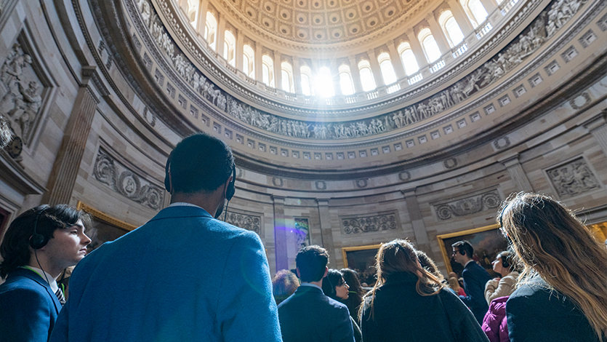
April 4, 2023 — Instead of heading home or to the beach for spring break, a group of Marist students ventured to Washington, D.C. for a public service career trip with the College. The trip gave students the unique opportunity to network with D.C.-based alumni and parents, attend career panels, visit iconic historic sites, and kindle their interest in future careers in public service and beyond.

Over 30 students from a variety of majors signed up to attend the trip led by Dr. Martin Shaffer, Dean of the School of Liberal Arts and Associate Professor of Political Science. The School of Liberal Arts teamed up with the Center for Career Services, the Marist Alumni Association, and the Center for Civic Engagement and Leadership to sponsor the trip and accompany the students as they navigated networking and the Capitol’s highlights.

“Our Marist D.C. Alumni network has grown enormously over the years, and we want to keep building that network as we help connect current students and recent graduates with our alumni in the Washington D.C. area,” said Dr. Shaffer. “During this year’s D.C. Public Service Career Trip, students got the opportunity to meet with alumni from Capitol Hill, executive branch agencies, advocacy groups, polling firms, museums and arts organizations, and many other public service fields.”
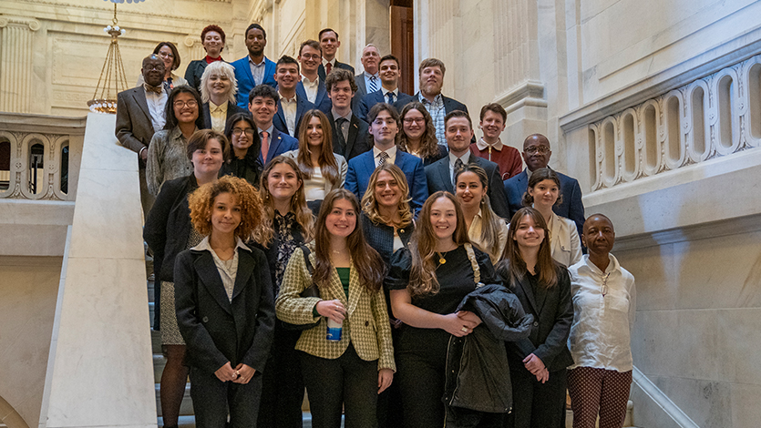
Marist Student Group with Faculty at US Capitol. Photo by Zachary Gawron.

“This is only the second time that we have sponsored this event, but it will now be held every spring break due to its success,” said Associate Director for the Employer Experience, Desmond Murray. “One alumna, Jenna Vanadia ’19, who attended the first trip as a student in 2019 served as a professional presenter on the 2023 panel. It is our goal to build a network of Marist alumni for current students who want to pursue careers in the DMV area (Washington, D.C., Maryland and Virginia).”

“When I came on the Marist Public Service Career Trip during my senior year four years ago, the advice panelists gave made me eager and hopeful for my future in Washington D.C.,” said Jenna Vanadia ’19. “Serving on the career panel as a D.C. alumnus this year was such a full circle moment and I hope the students got as much out of the trip as I did when I was in their shoes.”

During the trip, close to 100 people gathered for a Marist Alumni, Parent, and Student Networking Reception at the National Press Club to mingle and connect with fellow Red Foxes. More than 900 alumni now live in the D.C. area, making it an off-campus hub for Marist professionals to meet, reunite, and help one another succeed in one of the most important and influential places in America.

“I chose to come to D.C. because I’m interested in the public spheres,” said Navkiran Pandher ’23, Political Science and Paralegal student at Marist. “There are job options and career paths that I never thought existed until having conversations with alumni on this trip. Who knows, maybe I will end up here myself.”

“There are so many networks and jobs in D.C., making it a good place to start out and to meet new people,” said Hanna Bratt ’23, Social Work, Criminal Justice, Social Justice, and Sociology student at Marist. “I’m from the D.C. area so it was great to connect with Marist alumni from different fields and inspiring to learn their stories.”

[Embed Gallery Here]

Vice President of Diversity, Equity, and Inclusion (DEI), Dr. Edward Antonio spoke to reception attendees about the power of building relationships and how events like the Public Service Career Trip to D.C. help to uphold a strong, active, and diverse community among Marist networks.

“Marist is one of the few places where students open doors for each other both literally and figurately,” said Dr. Antonio. “When we network and network effectively, we open doors and opportunities for each other-doors to get to know each other, doors to be friends, and doors to think about where we fit in this world in terms of our careers and our prospects.”

During the trip, students attended several career panels where more than two dozen Marist alumni spoke about their direct experiences in national politics, global affairs, communications, and policy analysis and advocacy. Panelists gave advice about networking, internships, graduate school, mentorships, the job search, and growing their skill set and professionalism. They also discussed their own experiences as Marist students and encouraged students to take advantage of the collegiate opportunities that set them up for professional success and personal fulfillment.

[Embed Video Here]

When the trip concluded students shared their big takeaways and what they enjoyed the most.

“I would 100% recommend the D.C. trip to other students,” said Kiara Espinal ’25, Political Science, Social Justice, and Paralegal student at Marist. “My mind has been opened to the possibilities of what I could do post-college and I got to come to D.C. to see all of the monuments and museums like the African American Museum of History and Culture and Capitol Hill.”

“My biggest takeaway from the spring break D.C. trip has been the inspiration I’ve gotten from all the alumni I met,” said Zach Breton ’24, Public Relations student at Marist. “The alumni were super helpful and encouraging and gave good advice about networking, building resumes, and applying to jobs. I’m going to take back everything I learned as I look forward.”

To learn more about the Public Service Career Trip to D.C. contact Dr. Martin Shaffer and Desmond Murray.

Tags:
Student Life
Student Success
Alumni
Events
<style type="text/css">[data-ps-embed-type=slideshow] > iframe {position: absolute;top: 0;left: 0;}
</style>
<p>&nbsp;</p>
<div data-ps-embed-gid="G000024rcavaD6Ow" data-ps-embed-type="slideshow" id="slideshower" style="position:relative;height:0 !important;padding-bottom: 75% !important;width:100% !important;">&nbsp;</div>
<script src="https://marist.photoshelter.com/js/psEmbed.js"></script><script>
document.getElementById("slideshower").innerHTML = "";
_psEmbed("https://marist.photoshelter.com");
</script>
<p>&nbsp;</p>
<br />
Video Code:
<div class="video-responsive">
<center><iframe allow="autoplay; encrypted-media" allowfullscreen="" embedded="" frameborder="0" height="477" src="https://www.youtube.com/embed/mzNUurFBzpo" title="Marist College - Chair of Honor" width="848"></iframe></center>
</div>
<title></title>
<p>&nbsp;</p>
<style media="screen" type="text/css">.video-responsive{
overflow:hidden;
padding-bottom:56.25%;
position:relative;
height:0;
}
.video-responsive iframe{
left:0;
top:0;
height:100%;
width:100%;
position:absolute;
}
</style>

