Next Level Chef Alumna
HEADLINE: Marist Alumna Debuts Continues to Impress on Next Level Chef
SUMMARY: Michelle Calcagni ’14 competes in front of a national audience after the Super Bowl

BACK-END TITLE: Next Level Chef Alumna

Michelle Calcagni ’14, Photo courtesy of FOX.

March 31, 2023 — Marist alumna Michelle Calcagni ’14 continues to impress on the hit culinary competition, Next Level Chef, after making her debut the evening after the Super Bowl. Calcagni has advanced through another round, winning over the celebrity chef judges with her grit and culinary skills.

Calcagni was selected to chef Gordon Ramsay’s team in a culinary gauntlet against professional, social media, and home chefs from across the nation. Each week she advances, Calcagni gets closer to the ultimate prize of $250,000 and a professional culinary mentorship.

“Next Level Chef was a life-changing experience,” said Calcagni. “Despite initial fear about this incredible but big new opportunity, I found myself making my way to London to shoot in the Next Level Chef Studio and compete with 17 other chefs. With every challenge, I grew more confident in my abilities, proud of myself for stepping outside of my comfort zone and grateful to have been scouted and selected out of thousands of other talented cooks that had applied.”

Photo courtesy of FOX.
A Communications and Public Relations student at Marist, Calcagni (previously known as Michelle Pallotta), studied abroad at Marist Italy at The Lorenzo d’Medici Institute, where her love for cooking and travel flourished. Her time at Marist inspired her to begin her first food blog (@thestuffedartichoke on Instagram, soon to be @michelle_calcagni), which was her senior-year capstone project. Calcagni’s capstone project kick-started her career in culinary and travel media and later got her noticed to audition for the Next Level Chef TV Show.

“My communication courses at Marist helped teach me how to direct my passion for food into a feasible career path,” said Calcagni. “I launched an educational cooking website/blog/vlog as my senior capstone project at Marist, which was a major step in what would later become my culinary journey. Once I graduated, I decided I would continue to post photos on the Instagram account associated with the project - just as a digital portfolio of dishes I prepared and photographed. I had no idea that my college capstone would be the very project that would ultimately catch the right person’s eye and lead to my casting on Next Level Chef.”

Calcagni’s passion for food blends into her day-to-day work, as she is a Senior Brand Marketing Manager for Food & Wine, Travel + Leisure at Dotdash Meredith. Calcagni doubles as a marketing professional by day and an at home food blogger by night, grouping her into the home chef category on Next Level Chef.

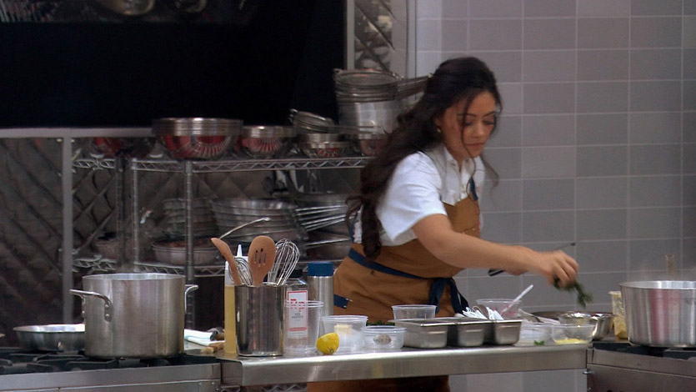
Photo courtesy of FOX.

While studying at Marist Italy, Calcagni immersed herself in Italian culture, cooking classes, and culinary experiences, expanding her perspective and her palate.

“While living in Florence during my time studying abroad at Marist, I was able to adopt and immensely appreciate the Italian lifestyle and culture–particularly as it relates to how they eat, how and where ingredients are sourced, the quality of each product, and the pride taken in the preparation of food,” said Calcagni. “I loved going to the market each day on my way home from class to pick up ingredients for dinner–the whole process felt like a romantic and unforgettable experience.”

Calcagni attributes some of her success to the support she received from her family, including sister Alexandria Pallotta '19/'21 and husband Anthony Calcagni ’13 who are both Marist alumni. Michelle also gives culinary credit to the memorable moments she had as a student living on campus.

“I discovered cooking “family dinners” for my housemates and friends helped me uncover my innate need to nurture by means of food and was a way for me to express my love and appreciation for my Red Fox Family,” said Calcagni. “I like to think I stole my husband’s heart through my food as well. I often reminisce about cooking meals for him, and even for his whole group of his football teammates in my kitchen in Foy A5. We are now expecting our first child, news I was happily surprised with while shooting Next Level Chef.”

As far as advice for current Marist students, Calcagni encourages them to step outside of their comfort zone, take calculated risks, and feed their passions.

“The universe has a way of working everything out just the way it’s meant to happen,” said Calcagni. “You will never regret putting yourself in a situation where you can learn something and grow. Whether your passion is food, or anything else, do your best to feed and nurture it. It will lead you in the right direction.”

Watch Calcagni compete on the next episode of Next Level Chef on Thursday, March 23 at 8pm ET on FOX.

Tags:
Alumni
School for Communications & the Arts
Marist Italy
Study Abroad

Draft Social: Marist Alumna competes on TV show Next Level Chef following the #SuperBowl 👩‍🍳 Link in bio to read more 🔗.

Twitter: @NextLevelFOX
Instagram: nextlevelcheffox

