North Road Communications
HEADLINE: Student-Run PR/Marketing Firm Now One of Nation’s Largest

SUMMARY: North Road Communications at Marist becomes one of the largest student-run IMC firms in the nation.

BACK-END TITLE: north road communications expands
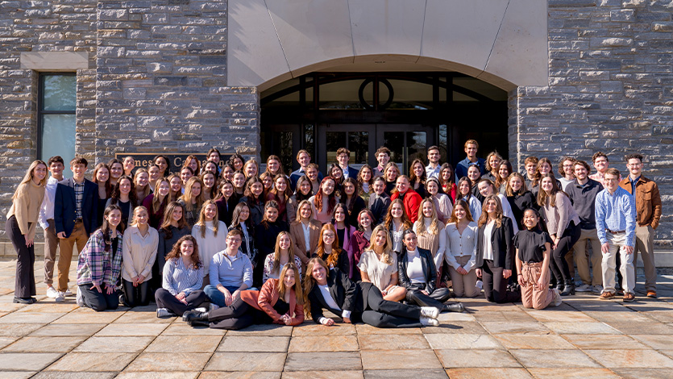
[NORTH ROAD TEAM PICTURE HERE]

March 20, 2023 — Marist students running North Road Communications (NRC) are getting the same hands-on public relations and marketing experience as seasoned agency professionals — well before they graduate. A fully student-run integrated marketing firm within the School of Communication and the Arts, students manage the entire client relationship process and provide a full portfolio of services to help non-profit organizations in the local community grow their brand.

Clientele and student membership has quickly expanded since the firm’s founding in 2011, making NRC one of the largest student-run integrated marketing communications (IMC) firms in the nation among colleges of comparable size. Their work now also extends internationally, working with clients in Florence, Italy.

NRC was founded by Marist’s Public Relations Student Society of America (PRSSA) Chapter and expanded beyond public relations to become a multi-faceted integrated marketing communications firm in 2016. NRC’s expansion and community impact are comparable to larger colleges and universities, growing from 64 students in the Fall of 2022 to 88 students for Spring 2023.

Within the firm, student members work free of charge for their non-profit organizations, many of whom have limited staff and funding. Without NRC’s help, many of these organizations would not have the same access to essential integrated marketing communications help.

Gallery Code - sent to Michelle. Maybe a caption like “Work samples by North Road Communications”

“We take pride in creating pro-bono, professional-grade work and fostering personal connections with some of the Hudson Valley’s hardest-working change makers, values that are consistent with the mission of Marist College as well,” said Grayce Shuker ’23, NRC Firm Director. “There is so much greatness happening in our firm right now but using our classroom-learned skills and our drive as students to give back to our community organizations is priceless.”

Students at NRC offer a range of communications services including media relations, social media, research & strategic communication, event planning, and more. The firm has 14 full-time community clients allocated among NRC student teams who support the communications needs of each client. Dedicated pitching, videography, and publicity teams also complete work for non-profit organizations on a project basis while an additional NRC Human Resources team oversees operations and makes sure collaborations run smoothly.

“As a result of real-world experience through North Road Communications, members are able to secure internships since interviewers are impressed with the level of professionalism and involvement in this organization,” said Grace Sander ’23, NRC Firm Director. “The portfolio of brands and notable agencies, firms, and companies where our members have secured positions is remarkable and diverse, both in industry and location.”
LEFT PHOTO: Grace Sander ’23 (left) with Grayce Shuker ’23 (right) in Poughkeepsie, NY. RIGHT PHOTO: Alexis Lee ’24 (left) with Beatriz Matarazzo ’24 (right) in Florence, Italy.

NRC is also expanding, as the firm is in the process of launching an NRC branch at Marist Italy while studying abroad. This uniquely positions NRC as an American student-run integrating marketing communications firm with an international presence.

“Our goal is to expand Marist’s global emphasis on community service to Italy,” said Alexis Lee ’24, NRC Global Firm Director. “We want to offer students participating in North Road Communications an opportunity to continue providing valuable publicity services to non-profit organizations in our global community while studying abroad. This will not only enhance their cultural understanding of Integrated Marketing Communications but also enable them to connect with the local community.”

“We already have a few Italian clients to whom we have introduced to NRC and have also made recent strides to implement non-profit remote clients from Ireland,” said Beatriz Matarazzo ’24, NRC Global Firm Director. “We met with Vanessa Nichol-Peters, the Director of Marist Italy, who welcomed our project with open arms and has been a tremendous resource along with Professor Jennifer Robinette, our NRC Faculty Advisor at Marist in Poughkeepsie.”

The School of Communication and the Arts continues to pursue community-oriented internships on campus that make experiential learning more accessible to students while simultaneously helping the local and global community. After a selective and rigorous application process, students who get accepted into NRC can now receive a one-credit experiential learning course for their participation, a unique collegiate opportunity compared to other student-run IMC firms in the country.

Dr. Jennifer Robinette, NRC Faculty Advisor and Senior Professional Lecturer at Marist, coaches and empowers the students to bring their ideas to life by encouraging their professional development, taking student members on communications agency tours, and serving as a resource as they continue to reach firm milestones.

“Having North Road Communications at Marist means that our students have the opportunity to build competitive resumes with marketable skills and portfolios of work illustrating their concrete experience, which most other college students will not have, throughout their college career by doing work for nonprofit clients in the community,” said Dr. Robinette. “This gives Marist students an edge in a highly competitive industry when applying for internships and when hitting the job market after graduation.”

To learn more visit North Road’s website. See NRC’s production of a client video below.

Unshattered: NRC Video: https://youtu.be/XHUFj-9AbFM

Tags:
- School of Communication and the Arts
- Public Relations
- Student Showcase
- Hudson Valley
- Marist Italy
- Study Abroad
Draft Social: Marist’s student-run IMC firm, North Road Communications, grows nationally and internationally 🇺🇸🇮🇹. 🔗 in bio to read more!
or
Marist student-run PR/Marketing firm now one of the nation’s largest 🔗 in bio to read more!

Working NRC Gallery Code:
<style type="text/css">[data-ps-embed-type=slideshow] > iframe {position: absolute;top: 0;left: 0;}
</style>
<p>&nbsp;</p>
<div data-ps-embed-gid="G0000Gt7x3gTaNoQ" data-ps-embed-type="slideshow" id="slideshower" style="position:relative;height:0 !important;padding-bottom: 75% !important;width:100% !important;">&nbsp;</div>
<script src="https://marist.photoshelter.com/js/psEmbed.js"></script><script>
document.getElementById("slideshower").innerHTML = "";
_psEmbed("https://marist.photoshelter.com");
</script>
<p>&nbsp;</p>
<br />
Working NRC Youtube Code:
<div class="video-responsive">
<center><iframe allow="autoplay; encrypted-media" allowfullscreen="" embedded="" frameborder="0" height="477" src="https://www.youtube.com/embed/XHUFj-9AbFM" width="848"></iframe></center>
</div>
<title></title>
<p>&nbsp;</p>
<style media="screen" type="text/css">.video-responsive{
overflow:hidden;
padding-bottom:56.25%;
position:relative;
height:0;
}
.video-responsive iframe{
left:0;
top:0;
height:100%;
width:100%;
position:absolute;
}
</style>

https://www.youtube.com/embed/XHUFj-9AbFM"

